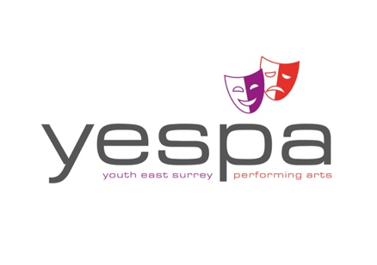

Attach
Photo here

YESPA Auditions - January 10th 2021

FIDDLER ON THE ROOF - AUDITION REGISTRATION FORM (attach photo + bring on the day)

First name: ………………………………………..Surname:…………………….....................................................

DATE OF BIRTH: ………………………………..………….AGE ON 5/8/21: ……...………………………………………

SCHOOL/COLLEGE: ………………..……………………………………………… HEIGHT:……..………..… Ft in / CM’s

I WOULD LIKE TO AUDITION FOR: - AN ENSEMBLE ROLE ONLY / A PRINCIPAL PART
(Delete as appropriate)

IF PRINCIPAL PART my 1st Choice is:…………………………........................................................................

Please also consider me for:………….……………………………………………………………and an Ensemble role.
(delete last phrase if you do not wish to be in the Ensemble if unsuccessful in your principal audition)

HOME TELEPHONE: …….……….……………..........………….…..………………………………………………………………..

NAME OF PARENT OR GUARDIAN:…………….………………………………………………………………………………….

PARENT/GUARDIAN MOBILE No.: ……………………………......................................................................

EMERGENCY CONTACT No.: (if different)……………………………………………………………………………………….

EMAIL ADDRESS FOR AUDITION RESULT: ………..…………………………………………………………………………..

MEDICAL ISSUES / ADDITIONAL NEEDS: ……………………………………………………………………………………….

HOW YOU HEARD ABOUT THE AUDITION: ………………………………..…….………………………………………….….………………………………………………………………
IMPORTANT: PLEASE CIRCLE ANY DATES BELOW THAT YOU WILL BE UNABLE TO ATTEND:

Month | Dates | Time
Jun/Jul | Sun 27th Th 1st , Sun 4th Th 8th, Th 15th | Sundays 10– 2pm; Thurs 7 – 10pm
Jul /  Aug | Wed 21st, Thurs 22nd, Fri 23rd  Mon 26th; Tues 27th ; Wed 28th ; Thurs 29th ; Fri 30th Mon 2nd , Tues 3rd – Last Hall Rehearsal. | 7 – 10pm  9 – 5pm  Mon 9 – 5pm & Tues 9 – 1pm
Aug | Into Harlequin Theatre, Redhill: Tues 3rd PM  Wed 4th (Band Call with Full Cast and Dress rehearsal)  Thurs 5th; Fri 6th & Sat 7th (x2) | Tues: Tech: 6 – 10.30pm  Wed: Band Call: 2 -5pm, Dress: 6-10.30  Eve shows: 6-10.30pm, Mat: 12.00-5pm

All personal details held on this form will be kept confidential and only used for administrative purposes by the YESPA Production team and the Director and Musical Director of the show. We cannot return photographs.

PLEASE BRING £10 / £15 (18+) MEMBERSHIP FEE IF NOT ALREADY ESPA / YESPA MEMBER.

